Task A (Basic Counts):

SELECT
CASE
WHEN price < 500 THEN 'Low Price'
WHEN price BETWEEN 500 AND 2000 THEN 'Mid Price'
ELSE 'High Price'
END AS price_category,
COUNT(*) AS total_products
FROM products
GROUP BY price_category;

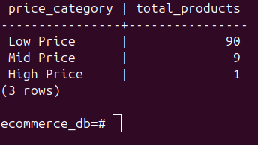

Task B (Condition on Groups):

SELECT
CASE
WHEN price < 500 THEN 'Low Price'
WHEN price BETWEEN 500 AND 2000 THEN 'Mid Price'
ELSE 'High Price'
END AS price_category,
COUNT(*) AS total_products
FROM products
GROUP BY price_category
HAVING COUNT(*) > 2;

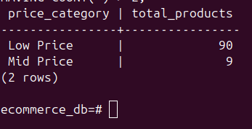

Task C (Statistics):

SELECT payment_status,
AVG(amount) AS average_payment
FROM payments
GROUP BY payment_status;

